**Laptop Harbor**



GROUP MEMBERS:

**ROHAIL LAZARUS**

***Student1391529***

**BUSHRA**

***Student1412223***

**SAMIULLAH**

***Student1429988***

**SYED HUMAYOON AZIZ**

***Student1430859***

**AHMED MUJTABA SHAHZAD**

***Student1397463***

**EMAAN AMEEN**

***Student1440270***

CURRICULUM:

**7062**

BATCH:

**2211B1**

FACULTY:

**SIR USAMA RIAZ**

CO-ORDINATOR:

**MS MUNAZZAH**

*CERTIFICATE*

THIS IS TO CERTIFY THAT THE DISSERTATION ENTITLED.

**Laptop Harbor**

IS SUBMITTED BY

**ROHAIL LAZARUS**

***Student1391529***

**BUSHRA**

***Student1412223***

**SAMIULLAH**

***Student1429988***

**SYED HUMAYOON AZIZ**

***Student1430859***

**AHMED MUJTABA SHAHZAD**

***Student1397463***

**EMAAN AMEEN**

***Student1440270***

IN THEIR PARTIAL FULFILMENT OF THE REQUIREMENT OF THE

AWARD OF THE APTECH COMPUTER CERTIFIED.



# 

# ACKNOWLEDGEMENT:

The success and final outcome of this project required a lot of guidance and assistance from many people and I am extremely privileged to have got this all along the completion of my project. All that I have done is only due to such supervision and assistance and I would not forget to thank them.

I respect and thank Aptech for providing me an opportunity to do the project work in ACE and giving us all support and guidance, which made me complete the project duly. I am extremely thankful to Aptech for providing such a nice support and guidance.

I owe my deep gratitude to our project guide SIR. USAMA RIAZ, who took keen interest on our project work and guided us all along, till the completion of our project work by providing all the necessary information for developing a good system.

**ROHAIL LAZARUS**

***Student1391529***

**BUSHRA**

***Student1412223***

**SAMIULLAH**

***Student1429988***

**SYED HUMAYOON AZIZ**

***Student1430859***

**AHMED MUJTABA SHAHZAD**

***Student1397463***

**EMAAN AMEEN**

***Student1440270***

INTRODUCTION:

The thirst for learning, upgrading technical skills and applying the concepts in real

life environment at a fast pace is what the industry demands from IT professionals

today. However busy work schedules, far-flung locations, and unavailability of

convenient time-slots pose as major barriers when it comes to applying the concepts

into realism. And hence the need to look out for alternative means of

implementation in the form of laddered approach.

The above truly pose as constraints especially for our students too! With their busy

schedules, it is indeed difficult for our students to keep up with the genuine and

constant need for integrated application which can be seen live especially so in the

field of IT education where technology can change on the spur of a moment. Well,

technology does come to our rescue at such times!!

Keeping the above in mind and in tune with our constant endeavor to use

Technology in our training model, we at Aptech have thought of revolutionizing the

way our students learn and implement the concepts using tools themselves by

providing a live and synchronous e-Project learning environment!

REQUIREMENT SPECIFICATION:

**INTRODUCTION:**

To be used efficiently, all computer software needs certain hardware components or the other software resources to be present on a computer. These pre-requisites are known as (computer) system requirements and are often used as a guideline as opposed to an absolute rule. Most software defines two sets of system requirements: minimum and recommended. With increasing demand for higher processing power and resources in newer versions of software, system requirements tend to increase over time. Industry analysts suggest that this trend plays a bigger part in driving upgrades to existing computer systems than technological advancements.

**HARDWARE REQUIREMENTS:**

A minimum computer system that will help you access all the tools in the

courses are a Pentium 166 or better

128 Megabytes of RAM or better

**HARDWARE REQUIREMENTS FOR PRESENT PROJECT:**

PROCESSOR: Intel dual Core, i3

RAM: 4 GB

HARD DISK: 250 GB

**SOFTWARE REQUIREMENTS:**

Software Requirements deal with defining software resource requirements and pre-requisites that need to be installed on a computer to provide optimal functioning of an application. These requirements or pre-requisites are generally not included in the software installation package and need to be installed separately before the software is installed.

**SOFTWARE REQUIREMENTS FOR PRESENT PROJECT:**

WINDOWS OS

JAVA

ANDROID SDK

NOTEPAD

SQL

DART

FLUTTER

**UI / ADMIN PANEL:**

The pictures of both panels describe the work and brief overview about the project. Some Screenshots are attached in the documentation.

**Have a look!**

# 

SCREEN SHOTS:

ADMIN PANEL:

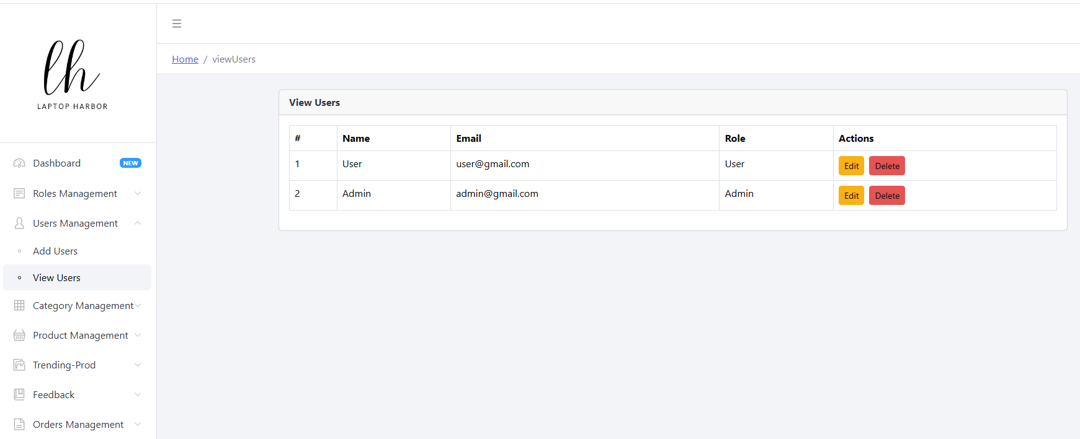

ADMIN PANEL CATEGORY:

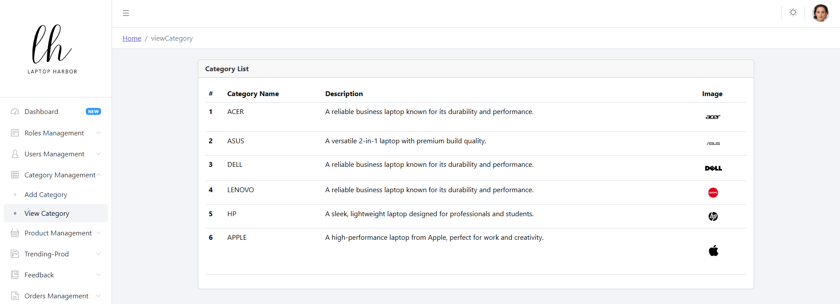

ORDERS IN ADMIN APNEL:

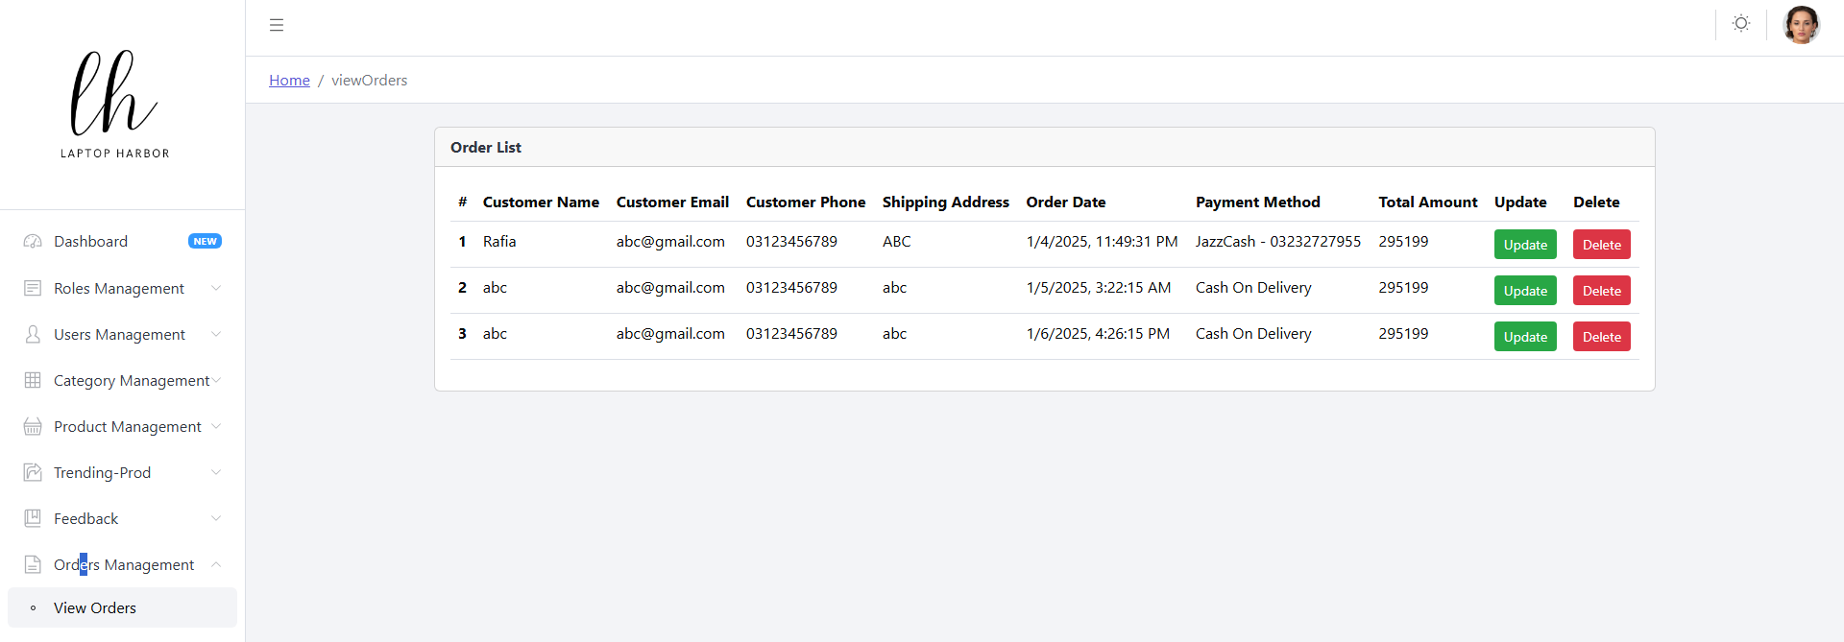

DISPLAY ADDED PRODUCTS:

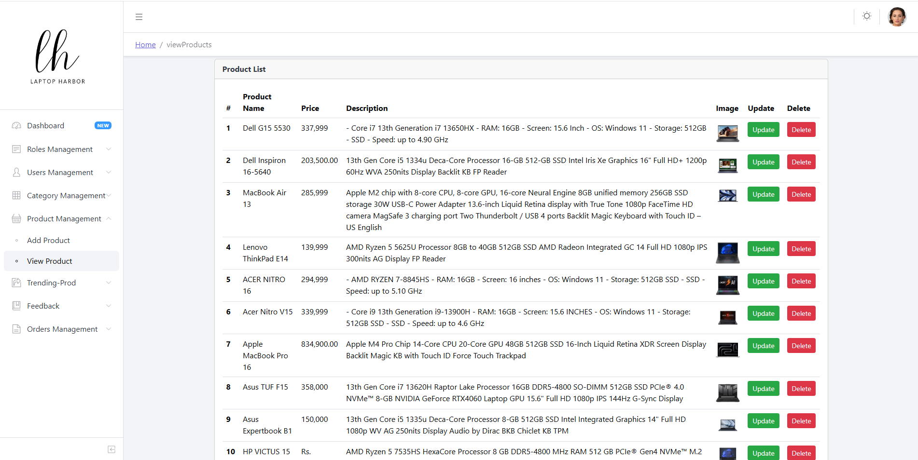

DISPLAY ROLES:

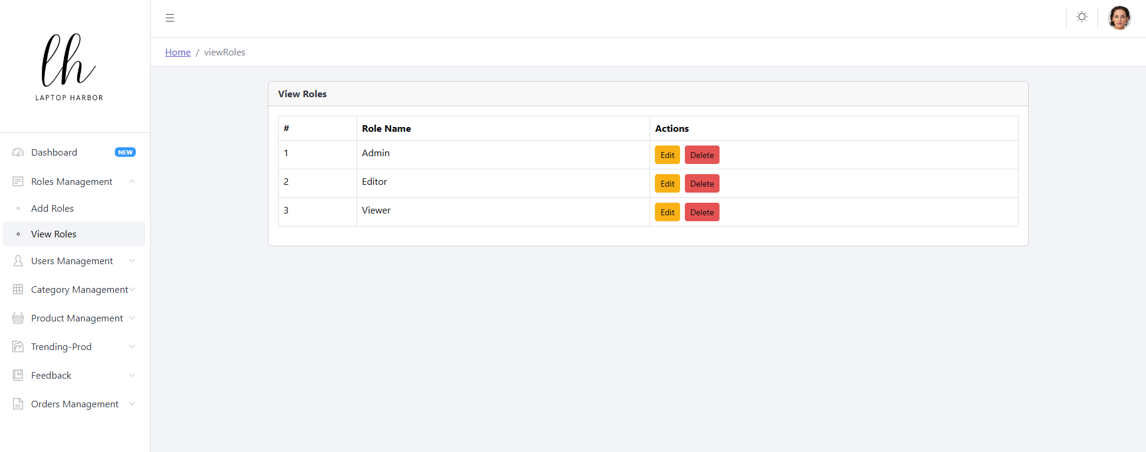

SUBMISSION CHECKLIST:

|  |  |  |  |
| --- | --- | --- | --- |
| **S#** | **LIST OF ITEMS** | **REMARKS** | **COMMENTS** |
| **1.** | Do All Pages link together? | **YES** | ✓ |
| **2.** | Authorization | **YES** | ✓ |
| **3.** | CRUD Operations | **YES** | ✓ |
| **4.** | Database Connection | **YES** | ✓ |
| **5.** | Job Addition | **YES** | ✓ |
| **6.** | Project ZIP file | **YES** | ✓ |

### CONCLUSION:

In conclusion, the symbiotic relationship between computer software and hardware is indispensable for efficient operation. System requirements serve as a crucial guide, delineating the necessary components and resources for optimal performance. Yet, they are not rigid mandates but rather flexible benchmarks that adapt to evolving technological landscapes. As software evolves to harness more processing power and resources, system requirements inevitably escalate, prompting users to upgrade their systems. This trend underscores the pivotal role of software demands in driving technological advancements and system upgrades. Thus, understanding and accommodating system requirements remain imperative for navigating the ever-changing realm of computing.